GESTURE BASED MOUSE

Capstone Project Report

Mid-Panel Evaluation

Submitted by:

(101603062) ATUL ANAND

(101603063) ATUL GUPTA

(101603067) AYUSH GUPTA

(101603069) AYUSH RAJ

BE 3rd Year, Computer Engineering

CPG No: 100

Under the Mentorship of

Dr Ravinder Kumar

Assistant Professor


Computer Science and Engineering Department

TIET, Patiala

October, 2019

ABSTRACT

As we know, for every electronic device, we need to perform some actions to control them. For example, in computers we use mouse cursor movements (left click, right click, double click) to perform different actions. There are mainly three ways to control mouse: wired mouse, touch-pad for laptops, joystick, touch screen technology and gesture recognition (facial expressions, hand, head, voice).In this report, we represent a novel approach for better human computer interaction (HCI) where we are using hand gesture recognition using real-time camera in order to overcome the drawbacks of existing methods and make the system cheaper and more user friendly. Our method is to use a camera and computer vision technology, such as image segmentation and gesture recognition, to control mouse tasks. Through web camera the real time video is captured. After that image processing is performed on each frame of that video. The frames are combined to recognize a pattern and accordingly particular actions are performed on the screen. This will be useful to promote controlling applications like computer games, browsing images etc.

ii
DECLARATION

We hereby declare that the design principles and working prototype model of the project entitled GESTURE BASED MOUSE is an authentic record of our own work carried out in the Computer Science and Engineering Department, TIET, Patiala, under the guidance of Dr. Ravinder Kumar during Jan 2019- Dec 2019.

Date: 20-10-2019

Roll No. | Name | Signature
101603062 | ATUL ANAND
101603063 | ATUL GUPTA
101603067 | AYUSH GUPTA
101603069 | AYUSH RAJ

Counter Signed By:

Faculty Mentor:

Dr. Ravinder Kumar

Computer Science & Engineering

Department

TIET, Patiala

iii

ACKNOWLEDGEMENT

We would like to express our thanks to our mentor Dr Ravinder Kumar. He has been of great help in our venture, and an indispensable resource of technical knowledge. He is truly an amazing mentor to have.

We are also thankful to Dr. Maninder Singh, Head, Computer Science and Engineering Department, entire faculty and staff of Computer Science and Engineering Department, and also our friends who devoted their valuable time and helped us in all possible ways towards successful completion of this project. We thank all those who have contributed either directly or indirectly towards this project.

Lastly, we would also like to thank our families for their unyielding love and encouragement.

They always wanted the best for us and we admire their determination and sacrifice.

Date: 20-10-2019

Roll No. | Name | Signature
101603062 | ATUL ANAND
101603063 | ATUL GUPTA
101603067 | AYUSH GUPTA
101603069 | AYUSH RAJ

iv
TABLE OF CONTENTS

ABSTRACT…………………………………………………………………………………… ii

DECLARATION…………………………………………………………………………….... iii

ACKNOWLEDGEMENT……………………………………………………………………. iv

LIST OF TABLES……………………………………………………………………………. vii

LIST OF FIGURES…………………………………………………………………………... vii

LIST OF ABBREVIATIONS………………………………………………………………... viii

CHAPTER 1- INTRODUCTION……………………………………………………………. 1

1.1 PROJECT OVERVIEW

1.2 NEED ANALYSIS

1.3 RESEARCH GAPS

1.4 PROBLEM DEFINITION AND SCOPE

1.5 ASSUMPTIONS AND CONSTRAINTS

1.6 APPROVED OBJECTIVES

1.7 METHODOLOGY USED

1.8 PROJECT OUTCOMES AND DELIVERABLES

1.9 NOVELTY OF WORK

CHAPTER 2 - REQUIREMENT ANALYSIS……………………………………………….. 6

2.1 LITERATURE SURVEY

2.1.1 Theory Associated With Problem Area

2.1.2 Existing Systems and Solutions

2.1.3 Research Findings for Existing Literature

2.1.4 The Problem That Has Been Identified

2.1.5 Survey of Tools and Technologies Used

2.2 STANDARDS

2.3 SOFTWARE REQUIREMENTS SPECIFICATION

2.3.1 Introduction

2.3.1.1 Purpose

2.3.1.2 Intended Audience and Reading Suggestions

2.3.1.3 Project Scope

2.3.2 Overall Description

2.3.2.1 Product Perspective

2.3.2.2 Product Features

2.3.3 External Interface Requirements

2.3.3.1 User Interfaces

2.3.3.2 Hardware Interfaces

2.3.3.3 Software Interfaces

2.3.4 Other Non-functional Requirements

v
2.3.4.1 Performance Requirements

2.3.4.2 Safety Requirements

2.3.4.3 Security Requirements

2.4 COST ANALYSIS

2.5 RISK ANALYSIS

CHAPTER 3 – METHODOLOGY ADOPTED…………………………………………… 14

3.1 INVESTIGATIVE TECHNIQUES

3.2 PROPOSED SOLUTION

3.3 WORK BREAKDOWN STRUCTURE

3.4 TOOLS AND TECHNOLOGIES USED

CHAPTER 4 - DESIGN SPECIFICATIONS……………………………………………..... 17

4.1 SYSTEM ARCHITECTURE

4.2 DESIGN LEVEL DIAGRAMS

4.3 USER INTERFACE DIAGRAMS

4.4 SNAPSHOTS OF WORKING PROTOTYPE MODEL

CHAPTER 5: CONCLUSIONS AND FUTURE DIRECTIONS …………………………. 22

5.1 WORK ACCOMPLISHED

5.2 CONCLUSIONS

5.3 ENVIRONMENTAL BENEFITS

5.4 FUTURE WORK PLAN

APPENDIX A: REFERENCES ……………………………………………………………… 24

vi

 | Table No. | Caption |  |  | Page No.
 | Table 1 | Research Gap Comparison |  |  | 3
 | Table 2 | Assumptions and Constraint of the proposed system. |  |  | 3
 | Table 3 | Research Findings for Existing Literature |  |  | 8
 | Table 4 | Cost Structure |  |  | 13
 | Table 5 | Table for Investigative Techniques |  |  | 14
vii
LIST OF TABLE

LIST OF FIGURES

 | Figure No. | Caption | Page No.
 | Figure 1 | Work Breakdown Structure | 15
 | Figure 2 | System Architecture of the project. | 17
 | Figure 3 | Sequence Diagram | 18
 | Figure 4 | Use Case Diagram | 19
 | Figure 5 | Activity Diagram | 20
 | Figure 6 | System Screenshot 1 | 21
 | Figure 7 | System Screenshot 2 | 21

viii

LIST OF ABBREVIATIONS

 | HRI | Human Robot Interaction
 | HCI | Human Computer Interaction
 | CC | Computer Control
 | GUI | Graphical User Interface
 | RADAR | Radio Detection and Ranging
 | H/W | Hardware
 | S/W | Software

ix
INTRODUCTION

1.1 Project Overview

Computer technology has tremendously grown over the past decade and has become a necessary part of everyday live. The primary computer accessory for HCI is the mouse. The mouse is not suitable for HCI in some real life situations, such as with HRI. There have been many researches on alternative methods to the computer mouse for HCI. The most natural and intuitive technique for HCI, that is a viable replacement for the computer mouse is with the use of hand gestures. This project is therefore aimed at investigating and developing a CC system using hand gestures. Most laptops today are equipped with webcams, which have recently been used insecurity applications utilizing face recognition. In order to harness the full potential of a webcam, it can be used for vision based control, which would effectively eliminate the need for a computer mouse or mouse pad. The usefulness of a webcam can also be greatly extended to other HCI application such as a sign language database or motion controller. Over the past decades there have been significant advancements in HCI technologies for gaming purposes, such as the Microsoft Kinect and Nintendo Wii. These gaming technologies provide a more natural and interactive means of playing videogames. Motion controls is the future of gaming. HCI using hand gestures is very intuitive and effective for one to one interaction with computers and it provides a Natural User Interface (NUI). There has been extensive research towards novel devices and techniques for cursor control using hand gestures. Besides HCI, hand gesture recognition is also used in sign language recognition, which makes hand gesture recognition even more significant.

Human Computer Interaction today mainly deals with natural interfaces. The GUI on Personal Computers is developed, providing an efficient interface for a user to interact with the computer and access the various applications effortlessly. Today technology used for interaction by mobile phone is mainly touch screen. But this technology is still not that cheap to be used in laptops and desktops. Our aim is to create a virtual mouse system having user friendly interface and an alternative to touch screen and present mousing systems. The computer vision devices (web camera) can be implemented and upgrade to the new input devices in the future. It gives the input command to the computer rather than just a function of taking photo or record video. We can do more implementation to transform the computer vision devices to become an input command device to reach the function as keyboard or mouse. One of the ways to give signal to computer vision devices is by using hand gesture. More specifically hand gesture is used as the signal or input modality to the computer. Certain signal can be recognized by computer as an input of what computer should do.

1

These will benefits the entire user without using a direct device and can do what they want as long as the computer vision device can sense it. These make computer user easier than using the keyboard or mouse. The future computer or laptop may eliminate the use of keyboard and mouse by substituting with a vision-based interpretation devices. Interaction between humans comes from different sensory modes like gesture, speech, facial and body expressions.

The main advantage of using hand gestures is to interact with computer as a non-contact human computer input modality. Our application presents a more effective and user friendly methods of human computer interaction intelligently with the usage of hand gestures. Functions of mouse like controlling of movement of virtual object have been replaced by hand gestures. The complexity involved is with the detection and recognition phases of the simulated virtual application. The challenges encountered are noisy environment which creates a big impingement on the detection and recognition performance of human hand gestures. The application has been designed to be cost effective and uses low cost input tools like webcam for capturing hand as input. Manipulation of virtual objects has been done through modeling of some predefined command based hand gestures.

1.2 Need Analysis

We had chosen this project with an interest of learning the direct interaction of humans with the consumer electronic devices. This takes the user experience to a whole new level. The gesture control technology would reduce our dependence on the age old peripheral devices hence it would reduce the overall complexity of the system. Initially this technology was considered in the field of gaming (like Kinect), but the application of motion/gesture control technology would be more diverse if we apply it to our other electronics like computers ,televisions, etc., for our day to day purposes like scrolling , selecting, clicking etc. Our primary objective in doing this project was to build a device inspired from Google’s Project Soli. It is a device which recognizes hand gestures and can be used to virtually control any electronic device. But the required hardware for making a device on these lines was not feasible, in terms of budget and time frame provided. So, we decided to build an introductory software implementation of the device which would eventually act as a virtual mouse.

1.3 RESEARCH GAP

Here present systems for controlling mouse movements are compared with respect to different parameters:

2
Table 1: Research Gap Comparison

Parameter | H/W usage | Touchscreen | Hand gestures | Hand gestures | Hand gesture based
Parameter | like mouse, |  | based on sensors | based on color | on video frames
 | joystick |  |  | detection
Cost | High | High | Moderate | Low | Low
Performance | High | Low | Low | Moderate | High
Accuracy | High | Moderate | Moderate | Moderate | Moderate
User Friendly | Yes | Yes | Yes | Yes | Yes
External |  |  |  |  | No
Hardware | Yes | No | No | No | No
Complexity | High | High | High | Moderate | Low

1.4 Problem Definition and Scope

There are generally two approaches for hand gesture recognition, which are hardware based, where the user must wear a device, and the other is vision based which uses image processing techniques with inputs from a camera. The proposed system is vision based, which uses image processing techniques and inputs from a computer webcam. Vision based gesture recognition tracking and gesture recognition. The input frame would be captured from the webcam and systems are generally broken down into four stages, skin detection, hand contour extraction, hand the skin region would be detected using skin detection. The hand contour would then be found and used for hand tracking and gesture recognition. Hand tracking would be used to navigate the computer cursor and hand gestures would be used to perform mouse functions such as right click, left click, scroll up and scroll down. The scope of the project would therefore be to design a vision based CC system, which can perform the mouse function previously stated.

1.5 Assumptions and Constraints

This section explains the assumptions and constraints about the project. They are mentioned in the Table below-

 | Table 2: Assumptions and Constraint of the proposed system.
SNO | Assumptions and Constraints
1 | Lack of dataset
2 | Slow processing of image
3 | Availability of high quality camera
4 | Only one hand should be in camera view at a particular instance
 | 3

1.6 Approved Objectives

The primary objectives of this project are as follows:-

- Record user gestures using web camera.

- Build a deep neural network using CNN.

- Train model to perform different actions on different gestures.

- Test model to identify user gestures.

- Perform action based on gestures.

1.7 Methodology Used

To complete our objective, we started with literature review to know the hardware and software requirements of our project also analyse the feasibility of our project in every manner. Prototypes will be discussed along with different modules and their respective coding. Afterwards we will move forward on the practical implementation.

Methodology to achieve our objectives as follows:

- Firstly, we need to capture Hand gesture using Webcam.

- Now convert the video gesture into individual frames.

- Finally, when the image has been properly processed, we track users hand movements frame by frame for cursor tracking.

- Now we match the recognized motion with available data sets

- Also, we recognize the user gestures at same time for performing predefined actions like zoom in, zoom out, scrolling etc on which the model has been already trained.

1.8 Project Outcomes and Deliverables

We had chosen this project with an interest of learning the direct interaction of humans with the consumer electronic devices. This takes the user experience to a whole new level. The gesture control technology would reduce our dependence on the age old peripheral devices hence it would reduce the overall complexity of the system. Initially this technology was considered in the field of gaming (like Xbox Kinect), but the application of motion/gesture control technology would be more diverse if we apply it to our other electronics like computers ,televisions, etc., for our day to day purposes like scrolling , selecting, clicking etc.

Following the some of the outcomes that we deliver-

- A software that recognizes hand movements and gestures of user and perform actions according to the movement.

- Eliminate the interaction with hardware devices for operating pc’s, laptop etc.
iii. Provide ease of access to the user.

- Performing actions with minimal hand movements.

4
1.9 Novelty of Work

Our motive was to create this technology in the cheapest possible way and also to create it under a standardized operating system. Various application programs can be written exclusively for this technology to create a wide range of applications with the minimum requirement of resources. Following are the key characteristics of our project-

i. More user friendly as compared to Arduino based mouses and gesture based mouse using colour caps.

- Our system has low complexity and based on low cost design.

- No hardware limitations

5
REQUIREMENT ANALYSIS

This section explains about the requirement which helped to make the project more accurate and reliable. This section includes Software Requirements, Cost Analysis, Work Breakdown Structure of the project.

2.1 literature Survey

In some passed decades Gesture recognition becomes very influencing term. There were many gesture recognition techniques developed for tracking and recognizing various hand gestures. The older one is wired technology, in which users need to tie up themselves with the help of wire in order to connect or interface with the computer system. Later on some advanced techniques have been introduced like Image based techniques which require processing of image features like texture etc. The literature survey includes the current knowledge including substantive findings, as well as theoretical and methodological contributions to the topic.

2.1.1 Theory Associated With Problem Area

The proposed system is vision based, that uses image processing techniques and inputs from a computer or laptop camera. The scope of the project would thus be to design a vision based system, which can perform the mouse function previously expressed. When user performs some gestures in front of web camera which is present on laptop, the webcam captures the real time video at a fixed frame rate and resolution which is determined by the hardware of the camera. The entire real time video is then divided into number of frames. Each frame will be processed individually. Then the frames will be clustered and an action will be performed accordingly.

2.1.2 Existing Systems and Solutions

- MICROSOFT KINECT

Kinect (codenamed Project Natal during development) is a line of motion sensing input devices produced by Microsoft. Initially, the Kinect was developed as a gaming accessory for Xbox 360 and Xbox One video game consoles and Microsoft Windows PCs. Based around a webcam-style add-on peripheral, it enabled users to control and interact with their console/computer without the need for a game controller, through a natural user interface using gestures and spoken commands. Microsoft discontinued Xbox Kinect after sometime but has extended Kinect for azure. For developers building cloud-powered solutions, Project Kinect for Azure combines the next generation of Microsoft’s category-defining depth sensor with Azure AI services to make the intelligent edge more perceptive than ever before.

6
How Kinect Works?

The software is what makes the Kinect a breakthrough device. Developers for the Kinect gathered an incredible amount of data regarding motion-capture of actual moving things in real-life scenarios. Processing all of this data using a special artificial intelligence machine-learning algorithm allows the Kinect to map the visual data it collects to models representing people of different backgrounds (age, height, gender, body type, clothing and more).

- PROJECT SOLI

Google’s Project Soli, which envisions a future where we will be able to control and manipulate wearables and other tech with simple hand gestures, has been causing excitement in the tech industry and beyond since it was revealed at the Google I/O conference 2015. Soli has the potential to connect our bodies with the virtual environment and unify our movements with the physical environment.

How Soli works?

  - The principle behind Soli is RADAR.

  - Radar is an object-detection system that uses radio waves to determine the range, angle, or velocity of objects.

  - A modulated electromagnetic wave is emitted toward a moving target that scatters the transmitted radiation, with some portion of energy redirected back toward the radar where it is intercepted by the receiving antenna.

  - The time delay, phase or frequency shift, and amplitude attenuation capture rich information about the target’s properties, such as distance, velocity, size, shape, surface smoothness, material and orientation.

  - Instead of static shapes, the key to Soli interaction is motion, range and velocity, where the sensor can accurately detect and track components of complex motions caused by a user hand moving and gesturing within sensing field.

- ARDUINO BASED GESTURE RECOGNISITION

The principle behind the Arduino based Hand Gesture Control of Computer is actually very simple. All you have to do is use two Ultrasonic Sensors with Arduino, place your hand in front of the Ultrasonic Sensor and calculate the distance between the hand and the sensor. Using this information, relevant actions in the computer can be performed.

The position of the Ultrasonic Sensors is very important. Place the two Ultrasonic Sensors on the top of a laptop screen at either end. The distance information from Arduino is collected by a Python Program and a special library called PyAutoGUI will convert the data into keyboard click actions.

7
2.1.3 Research Findings for Existing Literature

Table 3: Research Findings for Existing Literature

S. | Roll | Name | Paper Title | Tools/ | Findings | Citation
No | Number |  |  | Technology
.
1 | 101603062 | ATUL | A comprehensive | CNN | What is required | J. Schmid
 |  | ANAND | literature review |  | for the image | huber
 |  |  | on the gesture |  | processing
 |  |  | recognition |  | techniques to
 |  |  | techniques |  | covert the image
 |  |  |  |  | into individual
 |  |  |  |  | frames
2 | 101603062 | ATUL | A Simple Shape- | Image | Research paper | Amornche
 |  | ANAND | Based Approach | Processing | include various | d Jinda-
 |  |  | to Hand Gesture |  | techniques used | apiraksa,
 |  |  | Recognition |  | by the | Warong
 |  |  |  |  | researcher to | Pongstien
 |  |  |  |  | recognize | sak, and
 |  |  |  |  | gesture and | Toshiaki
 |  |  |  |  | perform action | Kondo
 |  |  |  |  | accordingly
3 | 101603062 | ATUL | A finger-tracking | Image pro | Learnt to
 |  | ANAND | virtual mouse | cessing & | convert gesture | Tsang,
 |  |  | realized in an | deep | into frames | W.-W.M.;
 |  |  | embedded system | learning |  | Kong-
 |  |  |  |  |  | Pang Pun
4 | 101603063 | ATUL | Gesture | Arduino | Used the | Premangs
 |  | GUPTA | Controlled Robot |  | Arduino | hu
 |  |  | using Arduino |  | structure and | Chanda,
 |  |  | and Android |  | hence controlled | PallabKan
 |  |  |  |  | the actions | ti
 |  |  |  |  | based on the | Mukherje
 |  |  |  |  | gesture. | e,
 |  |  |  |  |  | SubrataM
 |  |  |  |  |  | odak,
 |  |  |  |  |  | AsokeNat
 |  |  |  |  |  | h
5 | 101603063 | ATUL | Mouse | Image | Can’t wear those | Kamran
 |  | GUPTA | stimulation using | recognition | tapes for all the | Niyazi,
 |  |  | two coloured tape | based on | time so was not | Vikram
 |  |  |  | colour and | goof for routine | Kumar,
 |  |  | 8

 |  |  |  | distance | use | Swapnil
 |  |  |  | movement |  | Mahe,
 |  |  |  |  |  | Swapnil
 |  |  |  |  |  | Vyawahar
 |  |  |  |  |  | e
6 | 101603067 | AYUSH | Real-time Hand | Background | Learnt method | Shahzad
 |  | GUPTA | Tracking and | Subtraction | about removal | Malik
 |  |  | Finger Tracking |  | of background
 |  |  | for Interaction |  | so that only
 |  |  |  |  | hand gestures
 |  |  |  |  | are processed
7 | 101603067 | AYUSH | A survey on | Fusing data | Learned about | K N.
 |  | GUPTA | Human Computer | with optical | inertial motion | Shah, K
 |  |  | Interaction | motion | capture systems | R. Rathod
 |  |  | Mechanism Using | capture |  | and S. J.
 |  |  | Finger Tracking | system |  | Agravat
8 | 101603069 | AYUSH | A Method for | Computer | Image | Hojoon
 |  | RAJ | Controlling the | vision | segmentation | Park
 |  |  | Mouse Movement | algorithms | and deleting of
 |  |  | using a Real Time | for noise | noise form
 |  |  | Camera | reduction | image
9 | 101603069 | AYUSH | Portable Vision- | HCI | They block the | Chu-Feng
 |  | RAJ | Based HCI – A |  | improvement of | Lien
 |  |  | Realtime Hand |  | computer
 |  |  | Mouse System on |  | dependent devic
 |  |  | Mouse System on |  | es or system
 |  |  | Handheld Devices |  | es or system

2.1.4 The Problem That Has Been Identified

The problem identified through the literature survey is that, the detection result is not accurate when there are multiple hands in the camera view. Also if the light intensity is not good then also it will be a limitation for the project. The distance between camera and hand should also be at an optimal distance for proper detection of the hand. These problems can be further omitted in future work in the project.

2.1.5 Survey of Tools and Technologies Used

To carry out with the literature survey the methodology used by the members is to read all the research paper to get the wide idea about what all the research is done till now and how the specified project is innovated by the members. Our research is more focused on idea rather than research paper. We used various tools for making literature survey:

- Google Chrome to look for research papers.
- Adobe Crater for making PDF.
- Lucid Chart for diagrams

- Microsoft word to format and write the literature survey.

- Mendeley for references and to manage literature.

9
2.2 Standards

A standard is an authoritative principle or rule that usually implies a model or pattern for guidance, by comparison with which the quantity, excellence, correctness, etc., of other things may be determined.

i. IEEE 802.11 Standards

It is an arrangement of media get to control (MAC) and physical layer (PHY) determinations for executing remote neighbourhood (WLAN) PC correspondence. They are the world and most broadly utilized remote PC organizing norms, utilized in most home and office systems to permit workstations, printers, and cell phones to converse with one another and get to the Internet without associating wires.

ii. Camera Standards

Typical interfaces used by articles marketed as a "webcam" are USB, Ethernet and IEEE 802.11 (denominated as IP camera).

- H.264/MPEG-4 AVC video compression
- Full HD video recording (up to 1920 x 1080 pixels)

iii. Deep learning content standard

P3333.1.3 - This standard defines deep learning-based metrics of content analysis and quality of experience (QoE) assessment for visual contents.

2.3 Software Requirements Specification

The goal of this requirement specification document is to provide a unified view, common understanding of the functions of the prototype version for the Comment Sentiment Analysis Tool for English Language CSATEL and guidance to the development of the software system taking into consideration the project overall business plan, and user requirements.

2.3.1 Introduction

This section introduces about the project. It describes about specification of project. It also states about requirements of the project.

2.3.1.1 Purpose

This Software Requirements Specification (SRS) documents key specifications, describes a prototype in terms of functional and non-functional requirements for Gesture Based Mouse. The information documented, helps the intended audience to design and develop the product.

2.3.1.2 Intended Audience and Reading Suggestions

Primary readers of this document are the IOT researchers, Software and Hardware developers, professors, scholars etc. This document is intended for the following:

- Developers: In order to be assured they are developing the right project that full fills requirements provided in this document.

- Testers: In order to have an exact list of the features and functions that will respond according to requirements and provided diagrams.

10
- Documentation writers: To know what features and in what way they will explain.
What technologies are required, how the system will response in each user’s action etc.

- System administrators: In order to know exactly what they will expect from the system, right inputs and outputs and response in error situations.

2.3.1.3 Project Scope

In this report, an object tracking based virtual mouse application has been developed and implemented using a webcam. The system has been implemented in Python environment. We implemented basic mouse tasks such as clicking, and scrolling. In the future, we plan to add more features such as enlarging and shrinking windows, closing window, etc. This technology has wide applications in the fields of augmented reality, computer graphics, computer gaming, prosthetics, and biomedical instrumentation. Furthermore a similar technology can be applied to create applications like a digital canvas which is gaining popularity among artists. In case of computer graphics and gaming this technology has been applied in modern gaming consoles to create interactive games where a person’s motions are tracked and interpreted as commands. Most of the applications require additional hardware which is often very costly. Our motive was to create this technology in the cheapest possible way and also to create it under a standardized operating system. Various application programs can be written exclusively for this technology to create a wide range of applications with the minimum requirement of resources.

2.3.2 Overall Description

The description about the project is mentioned below under different sections. The section mainly explains the product perspective and Product features.

2.3.2.1 Product Perspective

We as a whole are living in advanced world in which we are managing various innovations. In the present day situation the vast majority of the cell phones are utilizing contact screen innovation to cooperate with the client. There is another innovation like touchscreen innovation which works superior to mouse or different gadgets however there are likewise a few disadvantages of such innovation like touch sensations may diminish over some undefined time frame. Also, it is as yet not shoddy to be utilized in work areas and workstations .And it will wind up hard to deal with such issues. So we thought there ought to be one framework which will defeated such disadvantages and works all the more adequately .And most significant is it ought to be more financially savvy and easy to understand .Hand motion acknowledgment utilizing image recognition using deep learning methods gives better execution. So we considered rather utilizing sensors, we can utilize just web camera so cost of the framework will get diminished extraordinarily. And furthermore in this framework there won't be utilized any outside equipment with the goal that presentation will get always kept up. Also, consequently all normal downsides will get incredibly diminished.

11
2.3.2.2 Product Features

We have developed gesture based mouse which will have all the features that are in a normal mouse that we use these days. The extra feature that we are providing as an advantage is that there will be no use of external hardware. Other product features are it acts as wireless actuators. The action will be performed by the help of image recognition techniques. The complexity of the system is also very low as compared to other gesture control mouse systems.

2.3.3 External Interface Requirements

The section explains about the interface requirements under this section. Some light is thrown on the user, hardware and software interfaces.

2.3.3.1 User Interfaces

User interface includes a simple desktop or a laptop interface The person should give the system privilege to open the camera which will afterwards used for detection of gesture.

2.3.3.2 Hardware Interfaces

No external hardware interface is used in our project. The only hardware you can say is used here is System camera. An external high quality web-cam can also be placed instead of the internal web-cam.

2.3.3.3 Software Interfaces

Python is used as the coding language for all the instances used in the project. Linux terminal can also be seen as a software interface as we are deploying our model on the former platform. Cuda platform is also used to run codes.

2.3.4 Other Non-functional Requirements

Non-functional requirements are important as all the requirements are considered below in this section.

2.3.4.1 Performance Requirements

As for this prototype version during the testing the performance of the system in terms of the efficiency and throughput given by the system after the integration of different components.

2.3.4.2 Safety Requirements

Camera should be of good quality so as if for an ordinary webcam the system is able to recognize the gesture the system displays an error. The same error message can also be displayed after there is no detection due to poor light and multiple hands in front of the camera.

12
2.3.4.3 Security Requirements

Our whole system interfacing is based on deep learning and machine learning techniques which includes training of model. As soon as the model begins to comply with the requirements, and successfully passes several stages of tests, the work of the developer usually ends, and the model enters the stage of operation, where some “bugs” may appear. These bugs from the data sets can create a security issue for the model. Developers usually do not have the entire set of data at the training stage. This can be a possible reason for future bugs.

2.4 Cost Analysis

The Table given below describes the cost analysis for the proposed system.

Table 4 – Cost Analysis

DEVICE | FUNCTION | COST
Microsoft LifeCam Studio | Able to detect gestures in high | 6500 INR
1080P HD Webcam | quality frames so that
 | efficiency will be increased

2.5 Risk Analysis

Very simply, a risk is a potential problem. It’s an activity or event that may compromise the success of a software development project. Risk is the possibility of suffering loss, and total risk exposure to a specific project will account for both the probability and the size of the potential loss. The risks included in our software development includes-

Scaling big data model to mobile devices for the application can be seen as a risk. Accuracy can also be seen as a measure of risk analysis as for the low quality images we may not have the optimized results.

13
METHODOLOGY ADAPTED

3.1 Investigative Techniques

Here descriptive and experimental investigative technique is used because when a hand is detected by our camera it is recording its frames. From frames it is recognizing gesture and a action is described corresponding to each gesture. It is also using comparative technique since when actions are performed, these are performed on the basis of comparison with the predefined data set.

Table 5- Table for Investigative Techniques

S. | Investigative Projects | Investigative | Techniques | Investigative |  | Projects
No. | Techniques | Description |  | Examples
1 | Descriptive | When a hand is detected by our |  | Designing | new | models
 |  | camera it is recording its frames |  | using | investigative
 |  |  |  | methods
2 | Experimental | When actions | are performed, | Machine | Learning, Deep
 |  | these are performed on the basis |  | Learning
 |  | of comparison with the predefined
 |  | data set.

3.2 Proposed Solution

Our idea is a innovative model mainly focused on adding a new feature to our personal computers. It is a alternative solution to conventional system that is mouse. Earlier to access a computer screen, to open or close a new folder we were limited to sitting near the mouse. But on using the gesture mouse computer screens can be easily monitored from a bit far away distance. Another major advantage of gesture mouse is elimination of hardware. Development of this model may cost initially but later it can be provided at very cheap rates since it is only software based and only required hardware is camera that is generally available in most of the computers now.

3.3 Work Breakdown Structure

We have mainly divided the work into five main categories. First being the research phase mainly comprising of identification of working idea, literature survey and requirement analysis. Here we mainly analyze weather the project we are making is feasible, weather it is having a future scope or not. Next comes the design and development phase where we plan how hardware and software will be implemented. And after that we finally start developing softwares to recognize images, then converting them to frames and recognizing gestures. And we keep on adding functionalities like performing various actions. After the final code is ready we enter into

14

testing phase where different functionalities of the program ae first tested individually and then combining them. After that documentation is done and finally product is ready. Now market research will be done to find its practical applications and sell in market. Here major work will also be done on marketing of product.
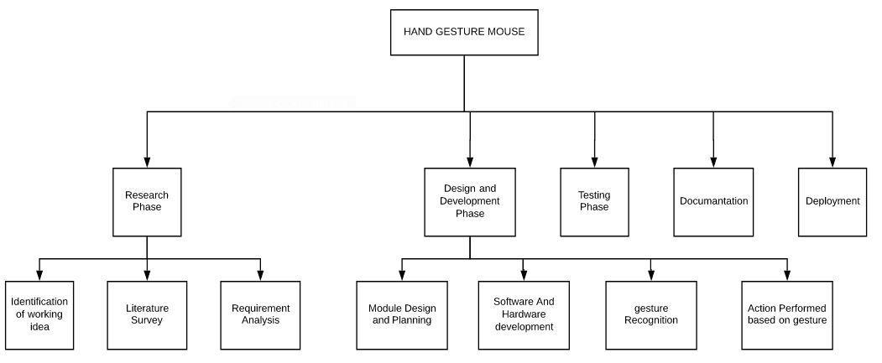

Figure 1 – Work Breakdown Structure

3.4 TOOLS AND TECHNOLOGIES USED

- Python: Python is a interpreted, object oriented, high-level programming language with dynamic semantics. Pythons’ simple, easy to learn syntax emphasizes readability and therefore reduces the cost of program maintenance. Python supports modules and packages, which encourages program, modularity and code reuse. The python interpreter and the extensive standard library are available in source or binary form without charge for all major platforms and can be freely distributed.

- OpenCV : OpenCV (Open Source Computer Vision Library) is an open source computer vision and machine learning software library. OpenCV algorithms can be used to detect and recognize faces, identify objects, classify human actions in videos, track camera movements, track moving objects, extract 3D models of objects, produce 3D point clouds from stereo cameras, stitch images together to produce a high resolution image of an entire scene, find similar images from an image database, remove red eyes from images taken using flash, follow eye movements, recognize scenery and establish markers to overlay it with augmented reality, etc.

15

- Py-torch : PyTorch is a computer software, specifically a machine learning library for the programming language Python, based on the Torch library, used for applications such as natural language processing. The interesting fact is, PyTorch is still in early-release beta, but the way everyone is adopting this deep learning framework at a brisk pace shows its real potential and power in the community. PyTorch doesn’t limit to specific applications because of its flexibility and modular design. It has seen heavy use by leading tech giants such as Facebook, Twitter, NVIDIA, Uber and more in multiple research domains such as NLP, machine translation, image recognition, neural networks, and other key areas.

16

DESIGN SPECIFICATIONS

The design specifications are considered in this section. All the phases such as the system phase and the user-interface are described below under the various section. It helps understand the project more conveniently.

4.1 System Architecture

The application is based on application tier. The client application tier consists of presentation layer and application layers. The top most layer i.e presentation layer records the gesture and perform action. The logical layer covers frame combination and conversion of image to frames. This comes under application layer.
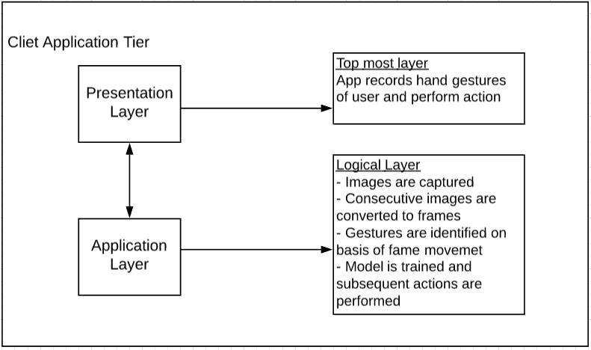

Figure 2: System Architecture of the project.

17
4.2 Design Level Diagrams

This area finishes up about the essential movement performed by every module and encourages the user to reach to the goal. The design phase consists of sequence diagram and class diagram.
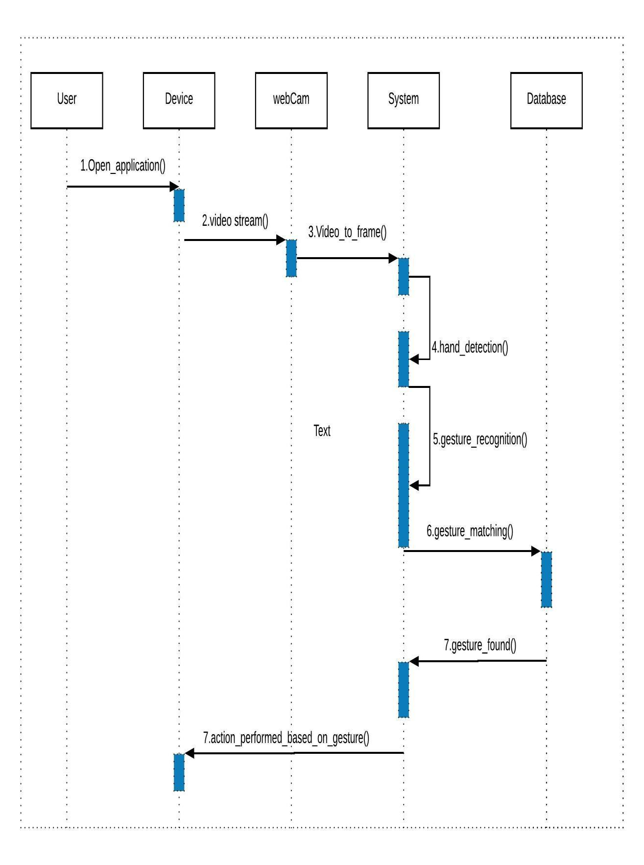

Figure 3: Sequence Diagram

18
4.3 User Interface Diagrams

This area finishes up about the fundamental correspondences held among every one of the parts likewise how user, system and other entity interacts with each other. It consists of usecase and activity diagram.
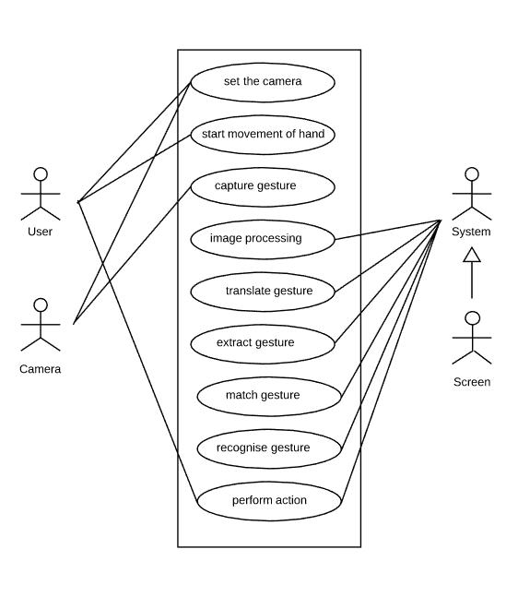

Figure 4- Use Case Diagram

19
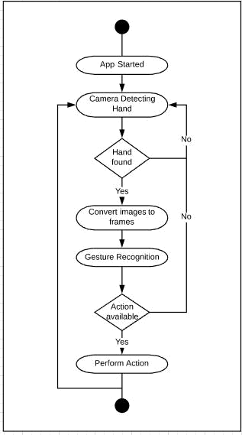

Figure 5- Activity Diagram

20

4.4 Snapshots of Working Prototype Model

This area incorporates about the depiction of the working model which are given underneath about the overall implementation of the code.
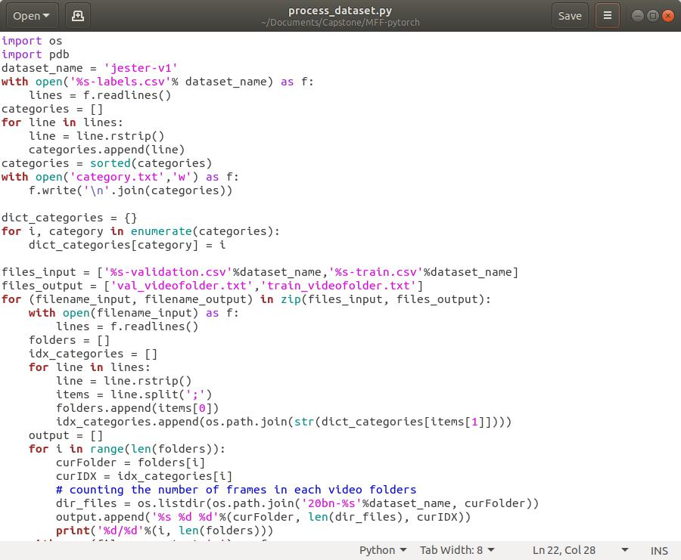

Figure 6 : System Screenshot 1
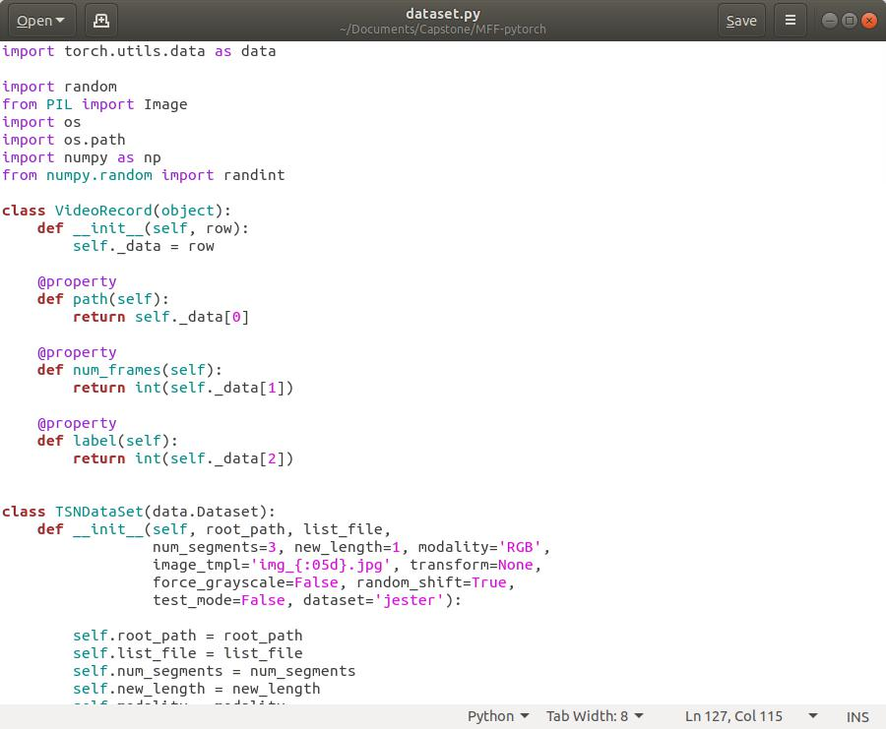

Figure 7: System Screenshot 2

21

CONCLUSIONS AND FUTURE DIRECTIONS

In this section the future directions of the project are discussed. The social environmental benefits to the society are highlighted.

5.1 Work Accomplished

Till now we have accomplished phase 1 & 2 i.e. recognition of gesture and converting them into frames. In this project we have successfully made a hand gesture mouse. Our main aim was to minimize use of hardware for controlling computer screens. Other objective was to access our computer screens from a distance so that we comfortably give presentations. Some of key accomplishments of this project are recognition of hand gesture through image processing. Here data set is divided in test train and data validation is there. Here gesture motion is captured using optical flow box method. Gestures are analyzed using pre-trained VNN model. Our data set we are having a action corresponding to each gesture and then that action is performed.

5.2 Conclusions

Since the major part of our project was based on image recognition tools, so we have learn a lot about image processing. We have learnt technologies converting images to frames. We also learnt about how to use a data set to give a particular output. Here our major focus was to develop the code and most of the time was devoted to improve the accuracy of the gesture recognition. Other major objective was to perform various actions and doing them efficiently. In future our major aim will be tolerate more errors like when any other hand comes into picture. We will be doing market research over this topic to find more practical applications like developing a gaming studio that will be controlled by movement of body movements. We finally conclude that this is a new model and there are lot of new opportunities that we can further explore through this project.

5.3 Environmental Benefits

One of the major aim of our project was reduction of hardware. Nowadays almost everyone is having a person computer and we are well aware about the quantity of mouse produced. Manufacturing of mouse requires plastic and other materials that firstly harm our environment during production and further after utilization when a traditional mouse becomes in-functional it becomes part of huge junks of e-waste that is a major concern to our environment now. So with this we can contribute a bit in reduction of e-waste.

22
5.4 Future Work Plan

There are some aspects of project which can be improved in future:

- Instead of using web-cam if better and more acquisition device can be used which even used in infrared for accuracy e.g. Kinect.

- Mechanism for hand detection is not accurate

- HU set of invariant moment are very basic descriptor as features of image which will not have good accuracy. A better descriptor can give good result but classification mechanism may change

- At last after product is ready and product becomes good enough to be sold in market, our major focus will be on marketing of the product and doing market research to find more practical implications of the gesture mouse.

23
REFERENCES

- Tsang, W.-W.M.; Kong-Pang Pun; “A finger-tracking virtual mouse realized in an embedded system”, Intelligent Signal Processing and Communication Systems, 2005. ISPACS 2005. Proceedings of 2005 International Symposium on, pp 781-784

- Amornched Jinda-apiraksa, Warong Pongstiensak, and Toshiaki Kondo, ”A Simple Shape-Based Approach to Hand Gesture Recognition”, in Proceedings of IEEE

International Conference on Electrical Engineering/Electronics Computer Telecommunications and Information Technology (ECTI-CON), Pathumthani, Thailand , pages 851-855, May 2010

- Cheoljong Yang; Yujeong Jang ; Jounghoon Beh ; Han, D. ; Hanseok Ko: "Gesture recognition using depth-based hand tracking for contactless controller application”,

Consumer Electronics (ICCE), 2012 IEEE International Conference on, On Page(s): 297-298

- Hojoon Park, “A Method for Controlling the Mouse Movement using a Real Time Camera”, Brown University, Providence, RI, USA, Department of computer science, 2008

- K N. Shah, K R. Rathod and S. J. Agravat, “A survey on Human Computer Interaction Mechanism Using Finger Tracking” International Journal of Computer Trends and Technology, 7(3), 2014, 174-177

- Shahzad Malik, “Real-time Hand Tracking and Finger Tracking for Interaction”,
CSC2503F Project Report, December 18, 2003

- Chu-Feng Lien, “Portable Vision-Based HCI – A Realtime Hand Mouse System on Handheld Devices”, National Taiwan University, Computer Science and Information

Engineering Department

- Kamran Niyazi, Vikram Kumar, Swapnil Mahe, Swapnil Vyawahare, “Mouse Simulation Using Two Coloured Tapes”, Department of Computer Science, University of Pune, India

- J. Schmidhuber Deep learning in neural networks: an overview Neural Netw., 61 (2015), pp. 85-117

- Premangshu Chanda, PallabKanti Mukherjee, SubrataModak, AsokeNath, “Gesture Controlled Robot using Arduino and Android”, IJARCSSE, Volume 6, Issue 6, June 2016.

24

